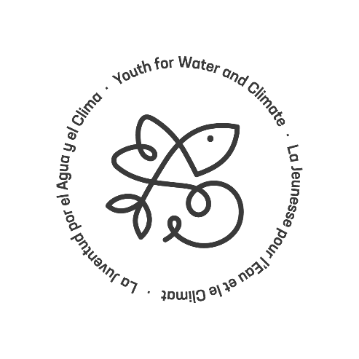
Youth for Water and Climate
Central Asia
Template for project brief

Please use this template to describe your project proposal and then attach this description to your submission. This is not about creating paperwork for you! In our view, the template fulfils different important objectives:
- it helps you think about what you want to achieve with your project and why and helps you reflect on how to successfully do this
- it helps you describe these elements in a structured manner and help you engage with potential sponsors (whether from within YWC our outside)
- it ensures that all the key points that will be assessed during our QA process are covered, and thus helps facilitate and accelerate the review process of the project
- it helps you prepare the elements that you will have to fill in in the submissions form
Please note that the template is complementary to the information which is requested on the submissions form.
Name of the organization: | Full name
Contact address:
E-mail: | Full name
Phone: | Full name
Date: | Click here to enter a date.
About the project
- Project title
Write your answer here.
- Overall information:

Type of project | New project Ongoing project
Project location | City or Province: Country:
If the project is ongoing, please specify when it started:

- 3. Project topic as per YWC pillars (Select one or more)

Water and agriculture
Water and health
Water-related risks
Sharing Water
Guidance on the pillars:
- Water and health: can be related to WASH, health campaigns, water-borne diseases, etc.
- Water and agriculture: can be related to irrigation, drought issues, rainwater harvesting, etc.
- Water-related risks: can be related to risk management, recovery and response to natural disasters, floods, drought, etc.
- Sharing water: can be related to transboundary cooperation, watershed management, water & peace, etc.

- Sustainable Development Goals (SDGs)
Please select the SDGs your project is addressing in the list below:

1 No poverty
2 Zero hunger
3 Good Health and well-being
4 Quality education
5 Gender equality
6 Clean water and sanitation
7 Affordable and clean energy
8 Decent work and economic growth
9 Industry, innovation and infrastructure
10 Reduced inequalities
11 Sustainable cities and communities
12 Responsible consumption and production
13 Climate action
14 Life below water
15 Life on land
16 Peace, justice and strong institutions
17 Partnerships for the goals
- Team (recommended maximum 250 words)
  - Who is leading the project (one person – a group)? Short description of the persons including their age
  - If applicable, will there be partners for implementing the project? Who are they?
  - If applicable, prior experience managing or implementing projects
  - If applicable, prior experience in working on the issue that is to be addressed

- The context and issue to be addressed (maximum 250 words)
  - What is the issue to be addressed?
  - Is the team aware of other similar situations or projects and what lessons were drawn from them in designing the project?

- Goals and objectives of your project (maximum 300 words)
  - What are the goals and objectives of the project?
  - Who are the intended beneficiaries? Why were they chosen and how are they expected to benefit?
  - How does the project relate to the themes and recommendations of the COP 21 White Paper?
  - How will the impacts of the project be sustained after the end of the project? Is there potential for replication or scaling up and why?

Objectives for this project entail:

- Implementation Framework (maximum 400 words)
  - What key activities will be carried out? Will the activities be carried out in phases? What is the timeline for implementing the different activities and phases?
  - Who will be in charge of implementing what? What are the roles and responsibilities of the different team members and of the partners?

Write your answer here.

- Budget and need for support (maximum 200 words)
  - Indicate overall budget and budget associated with each activity (including, if applicable, financing already secured and gap).
  - Explain how the project would benefit from the collaboration with YWC

Write your answer here.

- Activity calendar and timeline of the project
  - Please include a brief calendar of the activities highlighting when they will be implemented

- Any links to existing materials (e.g. blog posts, websites, articles, etc.) related to the project?

Website:
Video:
Crowdsourcing link:

